

**COCO NOIR**

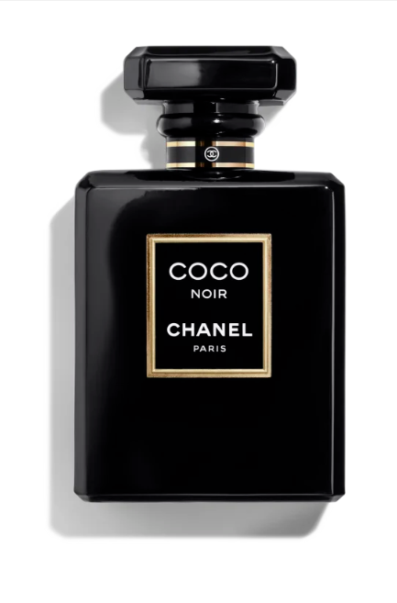**Coco Noir** by **Chanel** is a Amber Woody fragrance for women. **Coco Noir** was launched in 2012. Coco Noir was created by Jacques Polge and Christopher Sheldrake. Top notes are Grapefruit, Bergamot and Orange; middle notes are Rose, Geranium, Jasmine, Narcissus and Peach; base notes are Patchouli, Sandalwood, Olibanum, Tonka Bean, Vanille, White Musk, Cloves and Benzoin.

Coco Noir ilaunches in September 2012.

"For Coco Noir, I thought of Coco and of Coco Mademoiselle too, because it’s also part of the history. I wanted to continue exploring an entire esthetic range of CHANEL perfumery, a range that distinguishes itself from the Florals, one that is illustrated by Bois-des-Iles and Cuir de Russie. I took it up with Coco. It’s what I like to call the CHANEL Coromandel culture, what you see and feel in her apartment. The night vision of the ‘Orient that starts and ends in Venice’ imposed itself upon me and that is where I wanted to go.” perfumer Jacques Polge.

In 1984, there was Coco, that sumptuous blend of wood, resins, flowers, spices and fruit. A treasure trove of splendours and an endless source of discovery and sensual delight. Then, in 2001, came Coco Mademoiselle, a breath of air that lightens this cornucopia of fragrance, in which everything is simplified and accelerated in a radiant burst of fruit and flower. And today there is Coco Noir, a great nocturnal Baroque. Another journey in the wake of a Gabrielle who fully embraced the dazzle of black and Venice, incorporating them not only into her creations but into her life.